RMIT UNIVERSITY

School of Electrical and Computer Engineering

EEET1256 - Digital Design Automation

PROJECT –Hardware System Design using VHDL

Project Title:

Image Capture and Vector Display – CAMERA

Report prepared for:

Dr. Paul Becket
Dr. Stuart

Group Members:
Names | Student ID | Emails
Wei han | S3204911 | s3204911@student.rmit.edu.au
Munesh Daryanani | S3242815 | S3242815@student.rmit.edu.au
Ashraf Jamali | S9969940 | S9969940@student.rmit.edu.au

Date: June, 2009

Table of Contents

List of Figures………………………………………………………………………...3
List of Tables…………………………………………………………………….……3
Abstract……………………………………………………………………………….4
Acknowledgements…………………………………………………………………...4
Executive Summary………………………………………………..........................….4
Objective ……………………………………………………………………………...5
Introduction………………………………………………………………………..….6

Phase 1: Systems Design…………………………………………………………….6

Systems Overview..........................................................................................…............6
OV7620 Data Format………………………………………………………………….7
OV7620 Data Format Description ……………….…………………………………...8
OV7620 Chip-Operation...............................................................................................9
Project Master and Slaves Modes Module……………………………………..…….10
Connection of Master Device………………………………………………….…......10
Master Devices…………………………………………………………………….....11 Slave Devices …………………………………………………………………...…...11
Conflict-Protection Resistors ..............................................................................…....12
Camera Project - Design Process…………………………………………………….13
Camera Interface and Interpolation…………………………………………….……14
FPGA Interfaces and Working States………………………………………………..15
Timing Sequence.................................................................................................….....16
VGA Interface……………………………………………………………………......17

Phase 2: Systems Implementation using VHDL………………………………….18

Phase 3: Systems Testing…………………………………………………………..29

Phase 4: Systems Operation……………………………………………………….30

Phase 5: Systems Results/Output ………………………………………………....31

System Result Process …………………………………………………………….....33

Systems Test Bench Process………………………………………………………....36

Recommendations……………………………………………………………............42

Conclusion……………………………………………………………….…………...42

Reference……………………………………………………………….…………....43

Appendices…………………………………………………………….………….…44

List of Figures

Figure 1: Camera Project_ System level Structure
Figure 2: OV7620 Block Diagram
Figure3. Block Diagram of the Master and Slaves Modes
Figure4. Connection of conflict-protection resistors
Figure5. Conflict - protection Resistors
Figure 6: Systems Block Diagram
Figure 7: Camera Interface _Timing
Figure 8: VGA Timing Requirement
Figure 9: Camera Code using VHDL Module (quartus II –V.7.2)
Figure 10: Project Code using VHDL Module (quartus II –V.7.2)
Figure 11: Screen-shot of compilation and running process for camera systems
Figure 12: Board connected to Oscilloscope and Digital Analyser Probe Cable
Figure13: Camera Systems Waveform/Output Result obtained by Quartus II
Figure 14: SRAM on DE1 Board
Figure 15: Timing Diagram shows writing data in to SRAM
Figure 16: Camera System Waveform /output result obtained by Oscilloscope Device
Figure 17: Block diagram of the image processing
Figure 18: Test Bench Code using VHDL
Figure 19: Testbench_camera.do file
Figure 20: Test Bench Waveform /Output Result
Figure 21: Test Bench Waveform /Output Result
Figure 22: Test Bench Waveform /Output Result
Figure 23: OV76001 Pin out Diagram
Figure24. Digital Camera Development Process
Figure25. Digital Camera Equipment Setup /Connection

List of Tables

Table 1: Digital Output Format Type
Table 2: Description of Digital Output Format Type
Table 3: Interaction Pin
Table 4: Camera Interface Pin
Table 5: VGA Interface Pins
Table 6: SDRAM Interface Pins
Table 7: SRAM Timing Parameters on the DE1 board
Table 8: Timing Parameters for writing data into SRAM

Abstract

This report investigates the design process and implementation techniques for the digital camera project using hardware design tools VHDL to design and implement it.
This report begins with a brief overview of the project components and then the first phase of the project which is the design process of the system is initially outlined, then the report focus on the implementation phase of the project which involve using VHDL models to implement the project codes and then the operation phase and finally the testing phase of the system introduced.

Acknowledgements

This work has been carried out by the Project Group Camera at the RMIT University, School of Electrical and computer Engineering department and has been assisted and supported by our Academic staff (Dr Paul Beckett and Dr Stuart).

Executive Summary

The purpose of this report is to design, implement, test and operate a digital camera using VHDL module. This report contains several sections that are briefly described. The first section of the report provides a brief overview of the project components and the design process. The second section of the report describes the implementation process using VHDL modules to implement the project. The third section of the report will focus on the operation and testing of the project. The fourth section provides the results along with output simulation of the project, and finally the conclusion and recommendation section are provided at the end of the report.

Camera Report - Image Capture and Vector Display

Objective

The objective of this project is to capture monochrome images from a CMOS image chip (with a digital interface) and display them on the VGA monitor. It will require demonstrating a simulation and generating the timing at the interface to the camera and VGA monitor. For the camera module we have chosen OV7620, the resolution is the same as the VGA monitor (640x480). The image will be held for display in a double-buffered Frame Buffer, so that capturing a new frame and displaying the current one happen independently and simultaneously. A single button control will operate to “freeze the frame i.e., when the button is pressed the frame buffer swapping is suspended. The camera image is still captured, but the currently displayed image is held. Press the button again, and the image display resumes.

The following figure display a system level structure of the camera project:

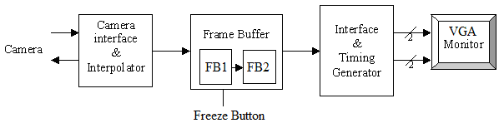

Figure 1: Camera Project_ System level Structure

Introduction:

This report provides an overview of the design and implementation process for the camera project. It mainly focuses on the process and operation for capturing monochrome images from a CMOS image chip (with a digital interface) and then display them on the VGA monitor. To do the above process it will require demonstrating a simulation and generating the timing for the camera and VGA monitor interfaces. The given camera for this project is the OV7620, which have the resolution same as the VGA monitor (640x480). Using this technique the image will be held for display in a double-buffered Frame Buffer, so that capturing a new frame and displaying the current can happen independently and simultaneously. A single button control will operate to “freeze the frame i.e., when the button is pressed the frame buffer swapping is suspended, and the camera image is still captured, but the currently displayed image is held. Press the button again, and the image display will resume.

- Phase 1: Systems Design:

To start the system design process we begin with some brief introduction of the technology used to do this project, and one of these technologies is OV7620 which is single chip CMOS VGA colour digital camera which is provided. Below is the simple overview of this camera technology,

Systems Overview:

OV7620 single _chip CMOS VGA color digital camera- General Description

OV7620 is a highly integrated high resolution (640x480) Interlaced / Progressive Scan CMOS digital color / black & white video camera chip. The digital video port supports 60Hz YCrCb 4:2:2 16Bit / 8 Bit format, ZV Port output format, RGB raw data 16Bit/8Bit output format and CCIR601/CCIR656 format. The built in SCCB interface provides an easy way of controlling the built-in camera functions.

OV7620 use in the following technology:

• Video Conferencing
• Video Phone
• Video Mail
• Still Image
• PC Multimedia

OV7620 Features:

- 326,688 pixels, 1/3” lens, VGA / QVGA format
- Read out - progressive / Interlace
- Data format - YCrCb 4:2:2, GRB 4:2:2, RGB Raw Data
- 8/16 bit video data: CCIR601, CCIR656, ZV port
- Video Timing - 525 line, 30 fps
- Wide dynamic range, anti-blooming, zero smearing
- SCCB (Serial Camera Control Bus) interface
- Electronic exposure / Gain / white balance control
- Image enhancement - brightness, contrast, gamma, saturation, sharpness, window, etc.
- Internal / external synchronization scheme
- Frame exposure / line exposure option
- 5 Volt operation, low power dissipation.

OV7620 Data Format:

The following table display the digital output format for the project:

 |  | Interlaced |  | Progressive Scan
Resolution |  | 640*480 | 320*240 | 640*480 | 320*240
YUV 4:2:2 | 16Bit | Y | Y | Y | Y
YUV 4:2:2 | 8Bit | Y | Y | Y | Y
YUV 4:2:2 | CCIR656 | Y | Y | Y | Y
RGB | 16Bit | Y | Y | Y | Y
RGB | 8Bit | Y | Y | Y | Y
RGB | CCIR6561 | Y | Y | Y | Y
Y/UV swap2 | 16Bit | - | - | - | -
Y/UV swap2 | 8Bit | Y | Y | Y | Y
U/V swap | YUV3 | Y | Y | Y | Y
U/V swap | RGB4 | Y | Y | Y | Y
YG | 16Bit | Y | Y | Y | Y
YG | 8Bit | - | - | - | -
One Line | 16Bit | - | - | Y | -
One Line | 8Bit | - | - | - | -
MSB /LSB swap5 |  | Y | Y | Y | Y
Table 1: Digital Output Format Type

Note: “Y” in the table means this combination is supported by OV7620

OV7620 Data Format type Description:

The following table describe all the digital Output format type

Format Type | Description
RGB | RGB CCIR656 format means 4-byte SAV and EAV is inserted at the beginning and ending of HREF, which are used to grab Vsync and Hsync information. So only use 8-bit data bus line and don’t need VSYNC and CHSYNC signal line.
Y/UV swap2 | Y/UV swap is valid only in 8 bit output. Y channel output sequence is Y U Y V ... rather U Y VY ....
Y/UV swap2 | To YUV format, U/V swap means UV channel output sequence swap. V U V U ... rather U V U V ... for 16 bit; V Y U Y ... rather U Y V Y ... for 8-bit.
Y/UV swap | To RGB format, U/V swap means neighbor row B R output sequence swap. So refer to preview RGB raw data output format, different format change accordingly.
MSB/LSB swap | MSB/LSB swap means: Default Y/UV channel output port relationship is:
Table 2: Description of Digital Output Format Type

OV7620 Chip Operation

Referring to FIG 2, OV7620 includes a 664x492 resolution image array, an analog signal processor, dual 10bit A/D converters, analog video mux, digital data formatter and video port, SCCB interface with its registers, the digital controls including timing block, exposure block and white balance. OV7620 is a 1/3 inch CMOS imaging device. The sensor contains approximately 326,688 pixels. It is base on field integration read-out system with line-by-line transfer and an electronic shutter with synchronous pixel read out scheme. The colour filter of the sensor consists of primary colour RG/GB array arranged in line alternating fashion. The majority of signal processing is performed in the analog processing block, which does color separation, matrixing, AGC, gamma correction, color correction, color balance, black level calibration, knee smooth, aperture correction, controls for the luminance and chrominance picture and anti-alias filtering. The analog video signals are based on the formula:
Y = 0.59G + 0.31R + 0.11B; where R, G, B is the equivalent color components in each pixel

U = R-Y;
V = B-Y;

Another output data format is YCrCb, its formula is as follows:

Y = 0.59G + 0.31R + 0.11B
Cr = 0.713 x (R - Y)
Cb = 0.564 X (B - Y)

The default output of the OV7620 is YCrCb, interlace scan, 16-bit mode.

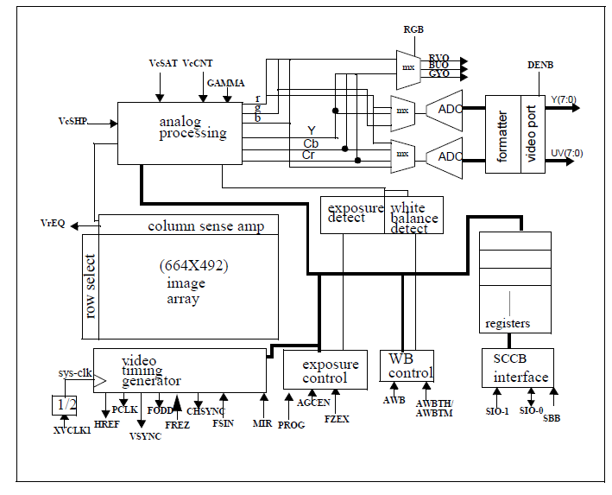
Figure 2: OV7620 Block Diagram

Project Master and Slaves Modes Module:

The structure of the system is shown in the Figure 8. This diagram illustrates the connection of one master with one slave. Multiple slaves may be connected on the same bus. A conflict-protection resistor of SIO_D is required for each slave.

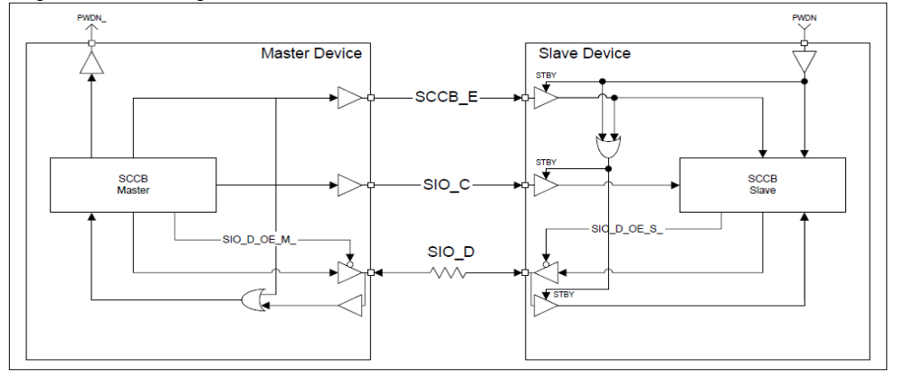

Figure3. Block Diagram of the Master and Slaves Modes

Connection of Master Device:

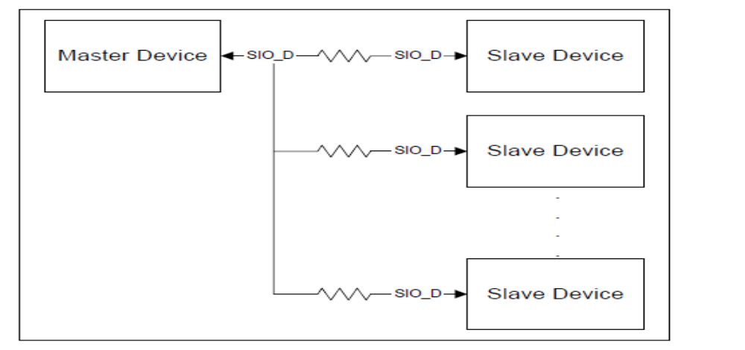
Figure4. Connection of conflict-protection resistors

Master Devices

The master device drives both SCCB_E and SIO_C signals, while either the master or slave(s) can drive the SIO_D signal. During the de-assertion of SCCB_E, the master must block the SIO_D input to avoid propagating unknown bus conditions due to bus float. During the Don’t-Care bit transmission, the master must ignore the status of SIO_D and keep asserting the subsequent phases. The PWDN_ is driven by the master to indicate the suspend mode cycle.

Slave Devices

The slave(s) receive the SCCB_E and SIO_C signals from the master, while either the master or the slave(s) can drive SIO_D. Input pads of the SCCB_E, SIO_C and SIO_D signals contain the standby (STBY) control terminal for reducing leakage current when the inputs are floating. Output terminals of those input pads are driven at logical 1 when STBY is asserted. This can avoid logical errors during suspend cycles.

PWDN controls STBY of SCCB_E. This means the output terminal of the SCCB_E input pad is driven at logical 1 during suspend mode cycles even though the master drives the input of SCCB_E at 0. The STBY control terminals of both SIO_C and SIO_D are controlled by PWDN and SCCB_E. During suspend mode cycles and the de-assertion of SCCB_E, the output terminals of SIO_C and SIO_D input pads are both driven at logical 1. During the Don’t-Care bit transmission, the slave(s) must avoid propagating unknown bus conditions.

Conflict-Protection Resistors
Incorporating series resistors between the SIO_D output of the master and the SIO_D input of the slave(s) can avoid short circuits when bus contention occurs.

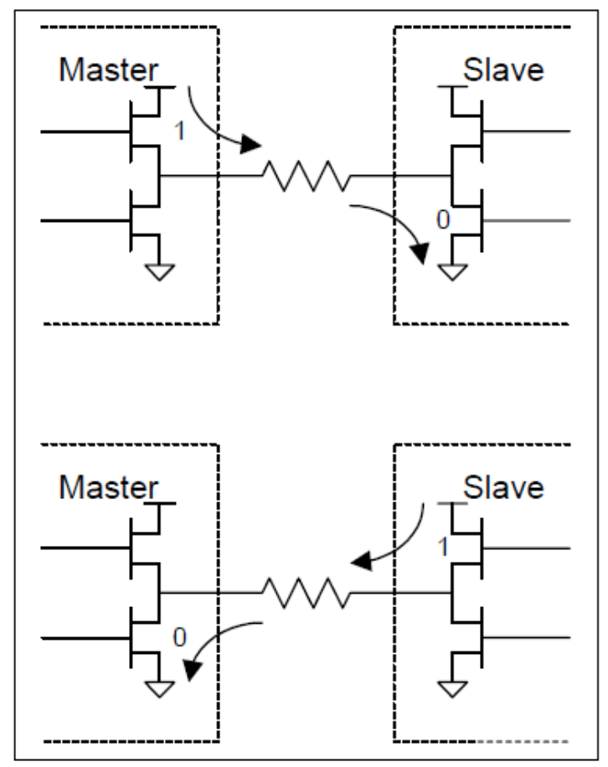

Figure5. Conflict - protection Resistors

Camera Project - Design Process
We begin our design process by initially designing the block diagram of the main systems as illustrated in the following diagram,

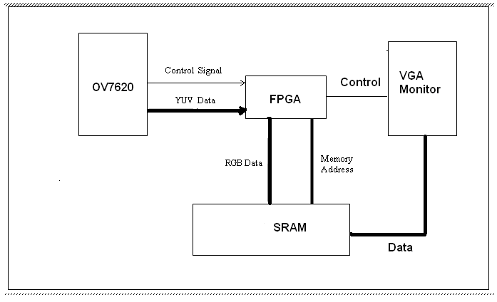

Figure 6: Systems Block Diagram

Functions of Systems Block Diagram:

The above Block diagram of the system operates as follow:

SRAM which is an internal control bit which is high means the OV7620 enter external RAM status. This is programmed by SCCB (register 27) or power-on read-in.

When SRAM=1, OV7620 all data bus will be tri-stated and ready to send the data. FPGA will reset all RAM Address block, after that, there are two methods to get one frame data from OV7620:

- FPGA sends an initial pulse to OV7620 AGCEN input pin
- FPGA sends a SCCB command to program OV7620 send Single frame data

The OV7620 output signal VS is the ACK signal from sensor, when VS is high means OV7620 is in ready status, when VS is low, means OV7620 will send one frame data.

Camera Interface and Interpolation:

The camera interface is one of the core modules in the system, whose job is responsible for interaction with the camera device. It basically retrieves digital data which represents lines for each frames of the video, which will be re-produced back in to video format for display on a VGA screen by the other modules of the system.

The interaction with the camera will be based upon CCIR601 communication protocol (Interlaced Mode) or ZV Port Interface Timing, depending on the type of monitor that will be used for display.

The pins that will be used for interactions are:-

Pin | Functionality
Y0-Y7 | For outputting the Digital data
VSYNC | 0: Indicates start of a new frame
HREF | 1: When transferring a pixel line of a frame
SBB,SIO-0,SIO-1 | Used for controlling the Built-in functions of the camera, which are part of SCCB
Table 3: Interaction Pin

The camera operates in MASTER mode. The data format output from the camera is YCrCb, interlace scan, 16-bit mode.
.

FPGA Interfaces and Working States

Interfaces:
FPGA communicates with the other system parts with three interfaces: Camera Interface, VGA Interface and SRAM Interface.
The interface to camera could use GPIO_0 interface, the pins which used in this interface is:

Pin | Functionality
GPIO_0(0) – GPIO_0(35) | I/O signals to Camera

Table 4: Camera Interface Pin

We used the following pins to design VGA interface, the pins and their functionality are listed here:

Pins | Functionality
VGA_R(0) –VGA_R(3) | VGA Red Signals
VGA_G(0) –VGA_G(3) | Green
VGA_B(0) –VGA_B(3) | Blue
VGA_HS | VGA H_SYNC
VGA_VS | VGA V_SYNC

Table 5: VGA Interface_ Pins

We used the following pins to design SRAM interface, the pins and their functionality are listed here:
SRAM pin assignments. Signal Name | FPGA Pin No. | Description
SRAM_ADDR[0] - | PIN_AA3 | SRAM Address[0]
SRAM_ADDR[1] | PIN_AB3 | SRAM Address[1]
SRAM_ADDR[2] | PIN_AA4 | SRAM Address[2]
SRAM_ADDR[3] | PIN_AB4 | SRAM Address[3]
SRAM_ADDR[4] | PIN_AA5 | SRAM Address[4]
SRAM_ADDR[5] | PIN_AB10 | SRAM Address[5]
SRAM_ADDR[6] | PIN_AA11 | SRAM Address[6]
SRAM_ADDR[7] | PIN_AB11 | SRAM Address[7]
SRAM_ADDR[8] | PIN_V11 | SRAM Address[8]
SRAM_ADDR[9] | PIN_W11 | SRAM Address[9]
SRAM_ADDR[10] | PIN_R11 | SRAM Address[10]
SRAM_ADDR[11] | PIN_T11 | SRAM Address[11]
SRAM_ADDR[12] | PIN_Y10 | SRAM Address[12]
SRAM_ADDR[13] | PIN_U10 | SRAM Address[13]
SRAM_ADDR[14] | PIN_R10 | SRAM Address[14]
SRAM_ADDR[15] | PIN_T7 | SRAM Address[15]
SRAM_ADDR[16] | PIN_Y6 | SRAM Address[16]
SRAM_ADDR[17] | PIN_Y5 | SRAM Address[17]
SRAM_DQ[0] | PIN_AA6 | SRAM Data[0]
SRAM_DQ[1] | PIN_AB6 | SRAM Data[1]
SRAM_DQ[2] | PIN_AA7 | SRAM Data[2]
SRAM_DQ[3] | PIN_AB7 | SRAM Data[3]
SRAM_DQ[4] | PIN_AA8 | SRAM Data[4]
SRAM_DQ[5] | PIN_AB8 | SRAM Data[5]
SRAM_DQ[6] | PIN_AA9 | SRAM Data[6]
SRAM_DQ[7] | PIN_AB9 | SRAM Data[7]
SRAM_DQ[8] | PIN_Y9 | SRAM Data[8]
SRAM_DQ[9] | PIN_W9 | SRAM Data[9]
SRAM_DQ[10] | PIN_V9 | SRAM Data[10]
SRAM_DQ[11] | PIN_U9 | SRAM Data[11]
SRAM_DQ[12] | PIN_R9 | SRAM Data[12]
SRAM_DQ[13] | PIN_W8 | SRAM Data[13]
SRAM_DQ[14] | PIN_V8 | SRAM Data[14]
SRAM_DQ[15] | PIN_U8 | SRAM Data[15]
SRAM_WE_N | PIN_AA10 | SRAM Write Enable
SRAM_OE_N | PIN_T8 | SRAM Output Enable
SRAM_UB_N | PIN_W7 | SRAM High-byte Data Mask
SRAM_LB_N | PIN_Y7 | SRAM Low-byte Data Mask
SRAM_CE_N | PIN_AB5 | SRAM Chip Enable

Table 6: SRAM Interface _Pins

Timing Sequence:

Camera Interface:

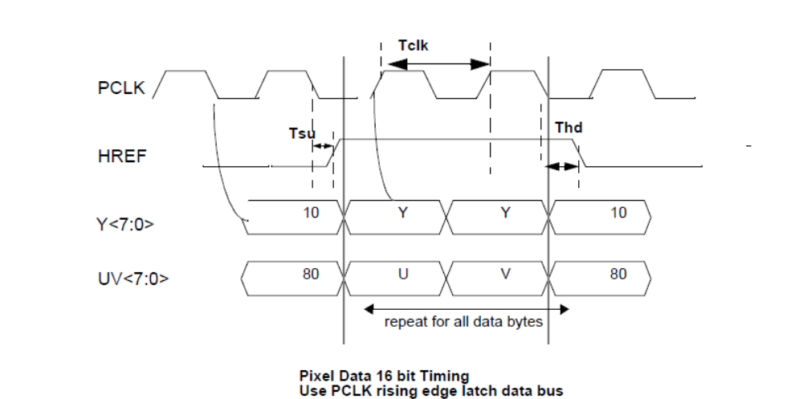

Figure 7: Camera Interface _Timing

The start and end of a new line is signified by the rising and falling edges of the HREF signal respectively. However we will need to emphasize on the Tsu and Thd of the HREF with respect to PCLK.

VGA Interface:

The basic timing requirement for the VGA operating as following:

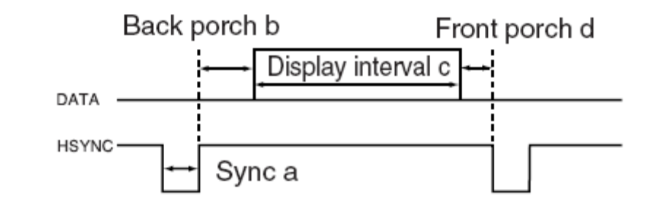
Figure 8: VGA Timing Requirement

An active-low pulse of specific duration (time a in the figure) is applied to the horizontal synchronization (hsync) input of the monitor, which signifies the end of one row of data and the start of the next. The data (RGB) inputs on the monitor must be off (driven to 0 V) for a time period called the back porch (b) after the hsync pulse occurs, which is followed by the display interval (c).

During the data display interval the RGB data drives each pixel in turn across the row being displayed. Finally, there is a time period called the front porch (d) where the RGB signals must again be off before the next hsync pulse can occur. The timing of the vertical synchronization (vsync) is the same as shown in Figure 4.12, except that a vsync pulse signifies the end of one frame and the start of the next, and the data refers to the set of rows in the frame (horizontal timing).

FPGA Working States:

The working states of the FPGA could be roughly divided into following phase:

- Camera initialization.

- If camera working the master mode, waiting the data transfer signal from camera.

- Receiving and storing the received data into buffer1 in SDRAM.

- If the freeze button doesn’t be push, transfer the data into buffer2.

- Reading the data from buffer2 and if necessary transforming the data into the

VGA format

- Outputting the data to VGA and displaying it.

- Phase 2: Systems Implementation using VHDL

Following the design process the implementation process of the systems begin which involve design and writing program for each components of our systems using VHDL modules (programming language), the following section of the implementation part of the report provide the details of the codes used to implement the camera systems

The following incluedes all theimplemetation codse for the Camera Project (Camera + VGA) .

Project Systems VHDL Code:

library ieee;
use ieee.std_logic_1164.all;
use ieee.numeric_std.ALL;
use IEEE.STD_LOGIC_UNSIGNED.ALL;

Entity Camera is
Port (
Y,UV: In std_logic_vector(7 downto 0);
VSYNC,HREF,PCLK,FODD: In std_logic;
VSYNC_O,HREF_O,PCLK_O: Out std_logic;
---------------------------------------------------------------------------------
SW : IN std_logic_vector(3 downto 0);
CLOCK_50 : IN std_logic;
VGA_B : OUT std_logic_vector(3 downto 0);
VGA_R : OUT std_logic_vector(3 downto 0);
VGA_G : OUT std_logic_vector(3 downto 0);
VGA_HS : OUT std_logic;
VGA_VS : OUT std_logic;
-------------------------------------------
SRAM_ADDR : out std_logic_vector (17 downto 0 );
SRAM_DQ : inout std_logic_vector (15 downto 0 );
-------------------------------------------
SRAM_CE_N,SRAM_OE_N,SRAM_WE_N,SRAM_UB_N,SRAM_LB_N : inout std_logic
---------------------------------------------------------------------------------
);
End Camera;

Architecture behaviour of Camera is

signal Count,first_data: std_logic:= '0';
signal Data1, Data2 : std_logic_vector (15 downto 0);
signal RESET : std_logic;
-------------------------------------------------
signal VGA_MEM_BUSY : STD_LOGIC := '0' ;
signal CMR_MEM_BUSY : STD_LOGIC := '0' ;
signal VGA_RAM_ADDR : std_logic_vector (17 downto 0);
signal VGA_RAM_DATA : std_logic_vector (15 downto 0 );
signal CMR_RAM_ADDR : std_logic_vector (17 downto 0);
signal CMR_RAM_DATA : std_logic_vector (15 downto 0 );
signal CMR_WE : std_logic;
signal VGA_WE : std_logic;
------------------------------------------------------
signal Address: std_logic_vector(17 downto 0);
signal Data : std_logic_vector(15 downto 0);

SIGNAL cl_count : integer := 0; -- the number of lines has drawn
Signal chcount : INTEGER := 0; -- line pixel counter
------------------------------------------------------
SIGNAL CLOCK_25 : std_logic; --25Mhz clock

CONSTANT HFP : integer := 16; --Front porch (horizontal) 0.6mus
CONSTANT HBP : integer := 48; --Back porch (horizontal) 1.9mus
CONSTANT HSYNC_TIME : integer := 96; -- H_Sync pulse lenght 3.8mus
CONSTANT LINE_PIXELS : integer := 634; -- Display pixels in one line is 25.4 mus
-- total pixel in one line is 794, last 31.7 muSec

-- total 525 lines in a field, last 16.6425 ms
CONSTANT FRAME_LINES : integer := 480; -- line number in one field
CONSTANT TOTAL_LINES : integer := 525; -- line number in one field

SIGNAL l_count : integer := 0; -- the number of lines has drawn
Signal hcount : INTEGER := 0; -- line pixel counter
constant TAA : time := 10ns;
constant TOHA : time := 3ns;

signal rdata : std_logic_vector (15 downto 0);

type mem is array(0 to 640) of std_logic_vector(3 downto 0);
signal r_array,g_array,b_array : mem;
attribute ramstyle : string;
attribute ramstyle of r_array, g_array, b_array: signal is "M4K";
------------------------------------------------------
------------------------------------------------------
Begin
RESET <= SW(1);
VSYNC_O <= VSYNC;
HREF_O <= HREF;
PCLK_O <= PCLK;

SRAM_CE_N <= '0';
SRAM_UB_N <= '0';
SRAM_LB_N <= '0';

Address_Generator: Process(PCLK)
---------------------------------------------------------------------------
Function yuvtorgb (signal y1 : in std_logic_vector(7 downto 0);signal y2 : in std_logic_vector(7 downto 0);
signal u : in std_logic_vector(7 downto 0);signal v : in std_logic_vector(7 downto 0))
return std_logic_vector is
variable data_v : INTEGER;
variable data_y1 : INTEGER;
variable data_u : INTEGER;
variable data_y2 : INTEGER;
variable red : integer range 0 to 255;
variable green : integer range 0 to 255;
variable blue : integer range 0 to 255;
variable rgb1 : std_logic_vector (15 downto 0);
begin
data_y1 := to_integer(unsigned(y1));
data_y2 := to_integer(unsigned(y2));
data_u := to_integer(unsigned(u));
data_v := to_integer(unsigned(v));
--------------------------------------------------------------------------
red := data_y1 + 140*(data_u-128)/100;
green := data_y1 - 34 *(data_v-128)/100 -71*(data_u-128)/100;
blue := data_y1 + 177*(data_v-128)/100;

red := red*15/255;
green := green*15/255;
blue := blue*15/255;

rgb1(3 downto 0) := std_logic_vector(to_unsigned(red,4));
rgb1(7 downto 4) := std_logic_vector(to_unsigned(green,4));
rgb1(11 downto 8) := std_logic_vector(to_unsigned(blue,4));
rgb1(15 downto 12) := "0000";
--------------------------------------------------------------
return rgb1;
end yuvtorgb;
--------------------------------------------------------------
Function ytorgb (signal y: in std_logic_vector(7 downto 0))
return std_logic_vector is
variable data_y : INTEGER;
variable red : integer range 0 to 255;
variable green : integer range 0 to 255;
variable blue : integer range 0 to 255;
variable rgb : std_logic_vector (15 downto 0);
begin
data_y := to_integer(unsigned(y));
-----------------------------------------------------------
red := data_y*15/255;
green := data_y*15/255;
blue := data_y*15/255;

rgb(3 downto 0) := std_logic_vector(to_unsigned(red,4));
rgb(7 downto 4) := std_logic_vector(to_unsigned(green,4));
rgb(11 downto 8) := std_logic_vector(to_unsigned(blue,4));
rgb(15 downto 12) := "0000";

return rgb;
end ytorgb;
--------------------------------------------------------------
variable iaddr : std_logic_vector (16 downto 0);
variable addr : integer;
--------------------------------------------------------------
Begin
if (rising_edge(PCLK)) then
If (RESET ='1') THEN
Address <= "000000000000000001";
CMR_MEM_BUSY <= '0';

cl_count <= 0;
chcount <= 0;

Count <= '0';
first_data <= '0';
else
if (VSYNC ='1' ) then -- start of a new field
Data1(15 downto 8) <= Y;
Data1( 7 downto 0) <= UV;

Count <= '0';
cl_count <= 0;
chcount <= 0;
first_data <= '0';

CMR_MEM_BUSY <= '0';
CMR_WE <= '1';
else
if (FODD = '1' ) then -- even Field
if (HREF ='1') then
--------------------------------------------------------
if (first_data = '1') then
chcount <= chcount +1;
else -- first pixel in a line
first_data <= '1';
chcount <= 1;
cl_count <= cl_count +1;
end if;

if (chcount <= 640 and cl_count <= 240) then
if ( Count = '0') then ---the first pixel
------------------------------------------------
addr := (cl_count-1) *320 + chcount/2 + 1;
iaddr := std_logic_vector(to_unsigned(addr,17));

Address <= '0'&iaddr;

Count <= '1';

Data1(15 downto 8) <= Y;
Data1(7 downto 0) <= UV;

if ( sw(3) = '0') then
Data <= ytorgb(Y);
else
--- Data <= yuvtorgb(Data1(15 downto 8), Data2(15 downto 8),Data1(7 downto 0), Data2(7 downto 0) );
end if;
------------------------------------------------
if (VGA_MEM_BUSY ='0') then
CMR_MEM_BUSY <= '1';
CMR_WE <= '0';
CMR_RAM_DATA <= Data;
CMR_RAM_ADDR <= Address;
end if;
------------------------------------------------
else -- second pixel, discard
Count <= '0';
Data2(15 downto 8) <= Y;
Data2(7 downto 0) <= UV;
CMR_MEM_BUSY <= '0';
CMR_WE <= '1';
end if;
else
CMR_MEM_BUSY <= '0';
CMR_WE <= '1';
end if;
else -- href = 0
CMR_MEM_BUSY <= '0';
CMR_WE <= '1';

chcount <= 0;
first_data <= '0';
-----------------------------------------------------------------
end if; -- end of href
-----------------------------------------------------------------
else -- odd field fodd is 0
CMR_MEM_BUSY <= '0';
CMR_WE <= '1';

cl_count <= 0;
chcount <= 0;
first_data <= '0';
end if; -- end of fodd
end if; -- end of VSYNC
end if; -- end of reset
end if; -- end of pclk
End Process;

pixel_draw : PROCESS(CLOCK_25,RESET) -- drawing pixels and blank pulses
variable iaddr : std_logic_vector (16 downto 0);
variable baddr1 : std_logic_vector (17 downto 0);
variable baddr2 : std_logic_vector (17 downto 0);
variable t_vgab : std_logic_vector(3 downto 0);
variable t_vgar : std_logic_vector(3 downto 0);
variable t_vgag : std_logic_vector(3 downto 0);
variable t_vga_addr : std_logic_vector (17 downto 0);
variable l_ext : std_logic := '0';
variable h_ext : std_logic := '0';
variable addr : integer;
BEGIN
IF RESET= '1' THEN
hcount <= 0;
l_count <= 0 ;
l_ext := '0';
h_ext := '0';
VGA_MEM_BUSY <= '0';
ELSIF rising_edge(CLOCK_25) THEN
IF l_count < FRAME_LINES THEN
if l_ext = '0' then -- first line
IF hcount < LINE_PIXELS THEN
if h_ext = '0' then -- first pixel
addr := l_count * 160 + hcount/2 + 1;
iaddr := std_logic_vector(to_unsigned(addr,17));
baddr1 := '0'&iaddr;
baddr2 := '1'&iaddr;
-------------------------------------------------------------------------------
if (CMR_MEM_BUSY = '0')then
if (SW(0) = '0') then
VGA_MEM_BUSY <= '1';
VGA_WE <= '1';
VGA_RAM_ADDR <= baddr1;

t_vgar := VGA_RAM_DATA(3 downto 0);
t_vgag := VGA_RAM_DATA(7 downto 4);
t_vgab := VGA_RAM_DATA(11 downto 8);

t_vga_addr := baddr2 ;
else
VGA_MEM_BUSY <= '1';
VGA_WE <= '1';
VGA_RAM_ADDR <= baddr2;

t_vgar := VGA_RAM_DATA(3 downto 0);
t_vgag := VGA_RAM_DATA(7 downto 4);
t_vgab := VGA_RAM_DATA(11 downto 8);
END IF;
END IF; -- end of CMR_MEM_BUSY
----------------------------------------------------------------------------------
VGA_R <= t_vgar;
VGA_B <= t_vgab;
VGA_G <= t_vgag;

r_array(hcount) <= t_vgar;
g_array(hcount) <= t_vgag;
b_array(hcount) <= t_vgab;
hcount <= hcount+1;
h_ext := '1';
elsif h_ext = '1' then --- second pixel
VGA_R <= t_vgar;
VGA_B <= t_vgab;
VGA_G <= t_vgag;

if (SW(0) = '0') then
VGA_WE <= '0';
VGA_RAM_ADDR <= t_vga_addr;
end if;

r_array(hcount) <= t_vgar;
g_array(hcount) <= t_vgag;
b_array(hcount) <= t_vgab;

hcount <= hcount+1;
h_ext := '0';
VGA_MEM_BUSY <= '0';
END IF; --- end of the h_ext
ELSIF hcount >=LINE_PIXELS and hcount < LINE_PIXELS+HFP+HSYNC_TIME+HBP THEN
VGA_R <= "0000";
VGA_B <= "0000";
VGA_G <= "0000";
hcount <= hcount+1;
ELSE
hcount <= 0;
VGA_R <= "0000";
VGA_B <= "0000";
VGA_G <= "0000";
l_count <= l_count+1;
l_ext :='1';
END IF; --- end of the hcount
ELSif l_ext = '1' then
IF hcount < LINE_PIXELS THEN
VGA_R <= r_array(hcount);
VGA_B <= b_array(hcount);
VGA_G <= g_array(hcount);

hcount <= hcount+1;
VGA_MEM_BUSY <= '0';
ELSIF hcount >=LINE_PIXELS and hcount < LINE_PIXELS+HFP+HSYNC_TIME+HBP THEN
VGA_R <= "0000";
VGA_B <= "0000";
VGA_G <= "0000";
hcount <= hcount+1;
ELSE
hcount <= 0;
VGA_R <= "0000";
VGA_B <= "0000";
VGA_G <= "0000";
l_count <= l_count+1;
l_ext :='0';
END IF;
END IF; --- end of the l_ext
ELSIF (l_count >= FRAME_LINES and l_count < TOTAL_LINES) THEN
IF hcount < LINE_PIXELS+HFP+HSYNC_TIME+HBP THEN
VGA_R <= "0000";
VGA_B <= "0000";
VGA_G <= "0000";
hcount <= hcount+1;
ELSE
hcount <= 0;
VGA_R <= "0000";
VGA_B <= "0000";
VGA_G <= "0000";
l_count <= l_count+1;
END IF;
ELSE
VGA_R <= "0000";
VGA_B <= "0000";
VGA_G <= "0000";
l_count <= 0;
END IF; --- end of the l_count
END IF; -- end of the clock_25
END PROCESS;

hsyn : PROCESS(CLOCK_25) -- horizontal syn
BEGIN
if rising_edge(CLOCK_25) then
if (hcount >= LINE_PIXELS + HFP and hcount < LINE_PIXELS + HFP + HSYNC_TIME) then
VGA_HS <= '0' ;
else VGA_HS <= '1';
end if;
end if;
END PROCESS;

vsyn : PROCESS(CLOCK_25) -- vertical syn
BEGIN
IF rising_edge(CLOCK_25) THEN
IF (l_count = FRAME_LINES +10 or l_count = FRAME_LINES +11) THEN
VGA_VS <= '0';
ELSE VGA_VS <= '1';
END IF;
END IF;
END PROCESS;

clk_25 : PROCESS(CLOCK_50,RESET) -- clock-25
VARIABLE count : INTEGER := 0;
BEGIN
IF RESET= '1' THEN
CLOCK_25 <= '0';
count := 0;
ELSIF rising_edge(CLOCK_50) THEN
IF count = 0 THEN
CLOCK_25 <= '1';
count := 1;
ELSIF count = 1 THEN
CLOCK_25 <= '0';
count := 0;
END IF;
END IF;
END PROCESS;

SRAM: process(VGA_RAM_ADDR,CMR_RAM_ADDR)
begin
assert(SRAM_CE_N = '0');
assert(SRAM_UB_N = '0');
assert(SRAM_LB_N = '0');

if CMR_WE = '0' then
SRAM_WE_N <= '0';
SRAM_OE_N <= '1';
SRAM_ADDR <= CMR_RAM_ADDR;
SRAM_DQ <= CMR_RAM_DATA;
elsif VGA_WE = '0' then
SRAM_WE_N <= '0';
SRAM_OE_N <= '1';
SRAM_ADDR <= VGA_RAM_ADDR;
SRAM_DQ <= VGA_RAM_DATA;
else
SRAM_OE_N <= '0';
SRAM_WE_N <= '1';
SRAM_DQ <= "ZZZZZZZZZZZZZZZZ";
SRAM_ADDR <= VGA_RAM_ADDR;
VGA_RAM_DATA <= SRAM_DQ after 10ns;
end if;
end process;
End behaviour;

--------------------------------------------------------------------------

Figure 9: Project Code using VHDL Module (quartus II –V.7.2)

- Phase 3: Systems Testing:

We begin testing process for each component by first compiling separate files and analysing the compiler output. We continue on compiling and analysing the code to have the entire Program run successfully and the output on the screen displayed with no errors. Then we use simulation tools and FPGA tools to obtain effective and accurate results appendix section of this document provides some information and details of some equipments used to design, debug, test and development process related to the system testing phase.

The following screen-shot obtain during the testing and compilation process of the camera project using Quarttus II tool.

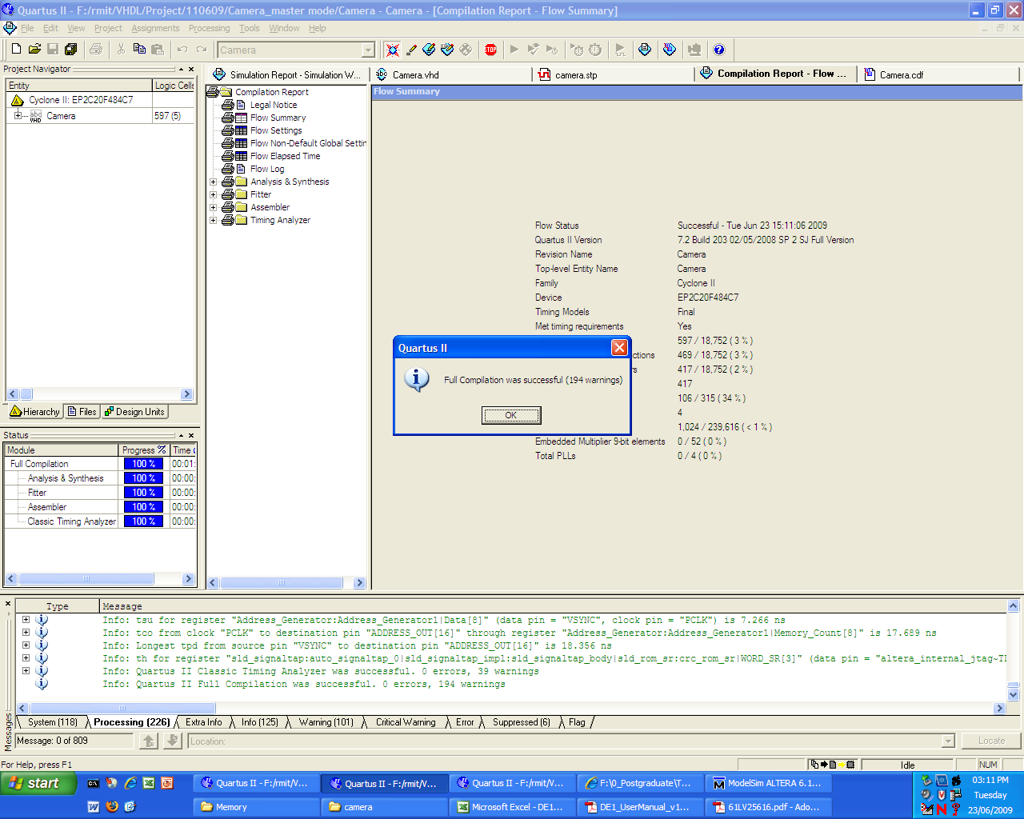

Figure 10: Screen-shot of compilation and running process for camera systems

- Phase 4: Systems Operation

After the testing process phase complete, that is after all the codes compiled and run and all the pin assignments are set properly and tested we begin the operation stage of the systems by operate each components individually using analyser measurement tools to see if they all operated as expected.

Appendix section of this document provides some information of all analyser and equipment that we used to operate the camera systems.

The following diagram shows the Project connection modules:

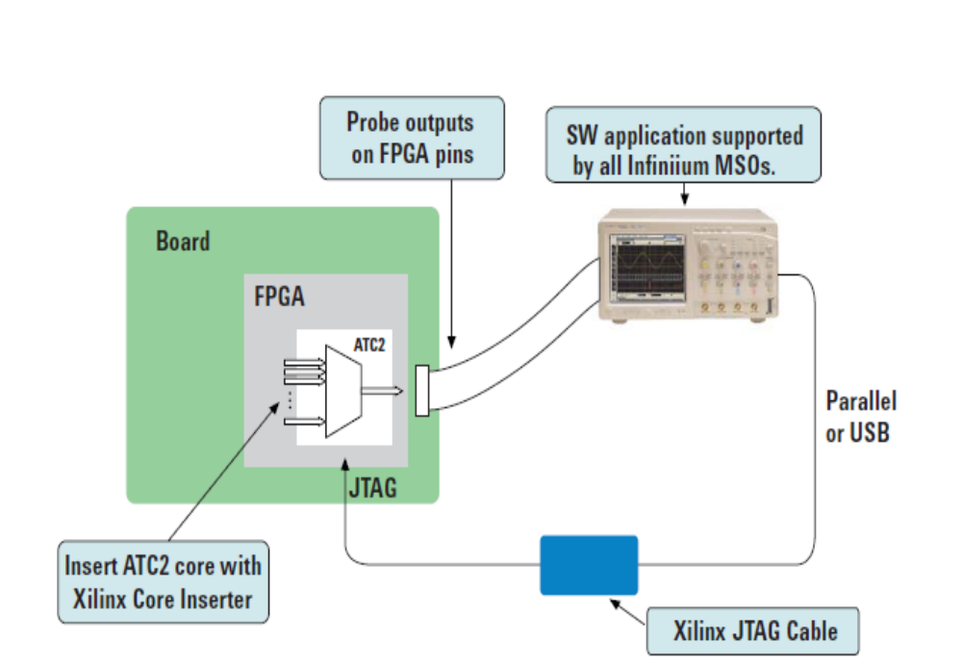

Figure 11: Board connected to Oscilloscope and Digital Analyser Probe Cable

- Phase 5: Systems Results/Output :

Following the operation stage of our system we begin to analyse and complete the result/output process of our systems, at this stage we using the simulation tools to produce output for each components that is camera interface, memory interface and VGA Monitor, some of the output/wave form result for each components are displayed here,

Camera Systems_ Output (Waveform Result):

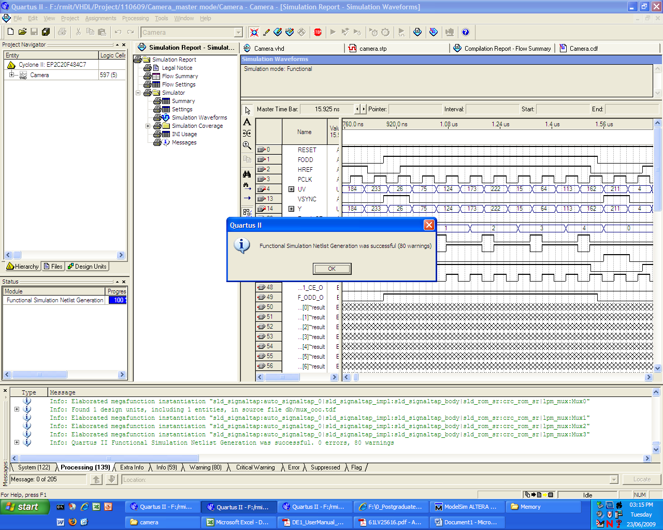

Figure12: Camera Systems Waveform/Output Result obtained by Quartus II

Systems Result Process:

Timing parameters for the SRAM on the DE1 board

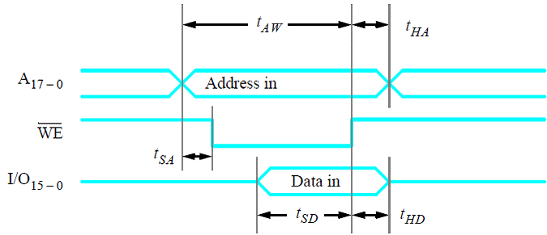

Figure 13: SRAM on DE1 Board

Parameter | Value
Parameter | Min | Max
t_{AW} | 8 ns | -
t_{SD} | 6 ns | -
t_{HA} | 0 | -
t_{SA} | 0 | -
t_{HD} | 0 | -
Table 7: SRAM Timing Parameters on the DE1 board

The above table gives the timing parameters for the SRAM on the DE1 board as specified by the datasheet. Due to the setup time t_{AW}, t_{SD} of the address and data respectively, that must be satisfied the WE signal cannot be assigned to ‘0’ for the duration when HREF is ‘1’. As the address goes through a transient state in changing from one address to another, this would cause wrong data to be written or over-writing of the data that is already present at these transient addresses, and vice-versa for when the data line goes through a transient. Therefore data are written to the SRAM after a particular time when both the data and the address field are stable. For ease of convenience in order to meet all the timing parameters discussed above, we are writing data in to the SRAM during the falling edge of the clock as shown by the timing diagram below.

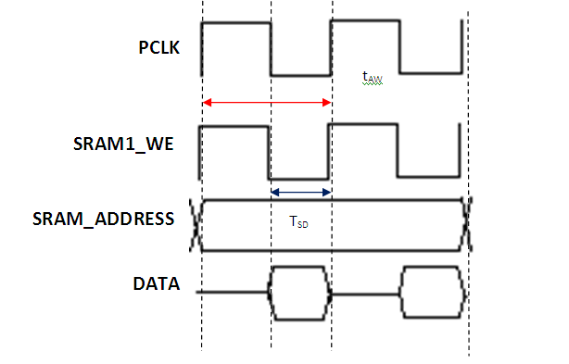
t_{AW}
T_{SD}

Figure 14: Timing Diagram shows writing data in to SRAM

Parameter | Value
t_{AW} | T_PCLK = 74 ns
t_{SD} | ½ * T_PCLK = 37 ns
t_{HA} | 0
t_{SA} | 0
t_{HD} | 0
Table 8: Timing Parameters for writing data into SRAM

Table above gives the timing parameters when writing data in to the SRAM during the falling edge of the clock cycle. These parameters meet the minimum time requirement during the write cycle of the SRAM as specified in the data sheet.

Oscilloscope System Output/Result

The following diagram display the output/results obtained by the Oscilloscope tool for the camera project, The VSYNC, HREF, FODD signals produced by the camera are re-drawn below as displayed on the oscilloscope, with the timing parameters measured using the cursors on the oscilloscope.
These timing parameters are taken in to account for simulation of the testbench signals so as to match the signals from the camera as close as possible (figure drawn not to scale).
The Camera interface was not successfully synthesized in this project. The simulation of the camera interface by itself with an appropriate test bench that closely matches the signals output from the camera shows the correct functionality of the module. However the actual problem why the module does not work properly could not be identified.

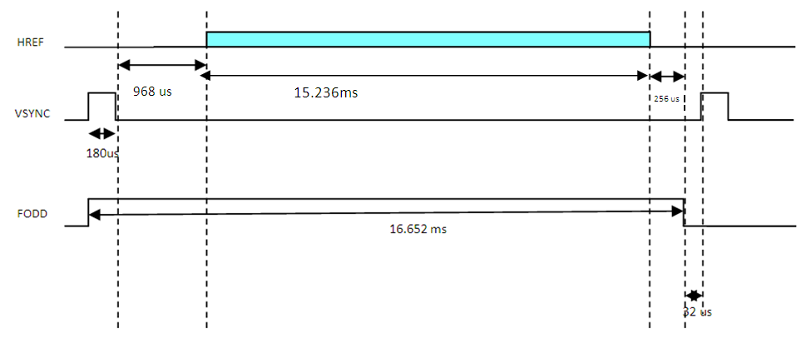
968 us

Figure 15: Camera System Waveform /output result obtained by Oscilloscope Device

Systems Test Bench Process

Test Bench Modules:

The VHDL part of the test bench is made of two modules:

- Camera Module
- Monitor Module.

Camera module simulates a black and white video digital camera. The input images are codified in a hex-image format.
The camera generates the digital signals usually required for video digital
Processing: video data, horizontal synchronism, vertical synchronism, Data validation and data sampling signal.

As illustrated below, there are four blocks or subsystems compose the image processing test bench system as proposed here. These subsystems are the Visor program, the camera VHDL module, the monitor VHDL module and the device under test described or instantiated in VHDL. The signal flow through the subsystems can be observed at figure 5. In first place, images or image sequence is passed to the Visor program to be converted from bitmap or SIF (Standard Interchange Format) to the hex-image format. Image in this format is used by camera module to generate the signals that stimulate the device under test. Signals generated by the device under test feed the monitor module that generates the hex file to be visualised or interpreted by the Visor program.

Camera
(camera.vhd)
Device under Test
VGA_Monitor
(monitor.vhd)
Bitmap / SIF
Converter
Bitmap / SIF

Viewer

Figure 16: Block diagram of the image processing

Test Bench Code using VHDL

The following display VHDL code for the Camera Modules:

Test bench code:-

entity TEST_CAMERA is
end;

library IEEE;
use IEEE.STD_LOGIC_1164.all;

architecture BENCH of TEST_CAMERA is
Component Camera is
Port (
Y,UV: In std_logic_vector(7 downto 0);
VSYNC,HREF,PCLK,FODD,RESET,Ram1_CE: In std_logic;
VSYNC_O,HREF_O,PCLK_O,Ram1_CE_O,Ram1_WE_O,Ram1_OE_O,F_ODD_O:Out std_logic;
ADDRESS_OUT: Out std_logic_vector(17 downto 0);
DATA_OUT: InOut std_logic_vector(15 downto 0);
Address_display,data_in_out_display,data_ram_display: Out std_logic_vector (0 to 6);
RGB: out std_logic_vector(15 downto 0);
Mem_busy: inout std_logic );
End Component;

signal Y,UV: std_logic_vector(7 downto 0);
signal VSYNC,HREF,PCLK,FODD,RESET,Ram1_CE: std_logic;
signal VSYNC_O,HREF_O,PCLK_O,Ram1_CE_O,Ram1_WE_O,Ram1_OE_O,F_ODD_O: std_logic;
signal ADDRESS_OUT: std_logic_vector(17 downto 0);
signal DATA_OUT: std_logic_vector(15 downto 0);
signal Address_display,data_in_out_display,data_ram_display: std_logic_vector (0 to 6);
signal RGB: std_logic_vector(15 downto 0);
signal Mem_busy: std_logic;

Begin

CLK_Gen: process is
Begin
PCLK <= '0' after 37 ns, '1' after 74 ns;
wait for 74 ns;
end process;

Data_Gen: process is
Begin
Y <= "10101010" after 37 ns, "01010101" after 111 ns;
UV <= "00001111" after 37 ns, "11110000" after 111 ns;
wait for 148 ns;
end process;

HREF_CLK: process is
Begin
--wait for 200 ns;
HREF <= '1' after 0 us, '0' after 44 us, '1' after 60 us;
wait for 60 us;
end process;

VSYNC <= '0' after 20 ns, '1' after 40 ns, '0' after 200040 ns;
FODD <= '0' after 20 ns, '1' after 40 ns, '0' after 16640040 ns;
RESET <= '0' after 1 ns, '1' after 10 ns;
Ram1_CE <= '0';

Camera_1:entity work.Camera port map (Y,UV,VSYNC,HREF,PCLK,FODD,RESET,
Ram1_CE,VSYNC_O,HREF_O,PCLK_O,Ram1_CE_O,Ram1_WE_O,Ram1_OE_O,F_ODD_O,ADDRESS_OUT,DATA_OUT,
Address_display,data_in_out_display,data_ram_display,RGB, Mem_busy);

end BENCH;

Figure 17: Test Bench Code using VHDL

The following displays testbench_camera.do file code for the Modelsim Simulation
testbench_camera.do:-
vcom Camera.vhd
vcom testbench_camera.vhd
vsim test_camera
add wave -r /*
run 17 ms

Figure 18: Testbench_camera.do file

Test Bench Waveform/ Output result

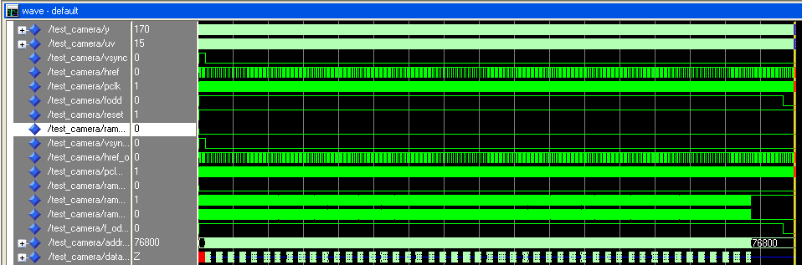

Figure 19: Test Bench Waveform /Output Result

The figure above shows that the address signal stops incrementing once it reaches the address 76800, since it is the last address that data is written to.

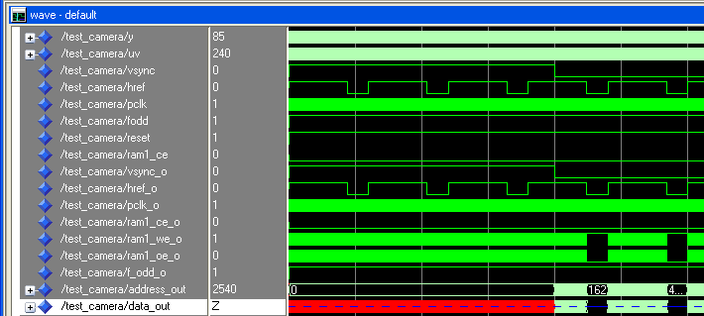

Figure 20: Test Bench Waveform /Output Result

As seen from the above figure, the address stars incrementing once:
VSYNC = ‘0’
HREF = ‘1’
FODD = ‘1’

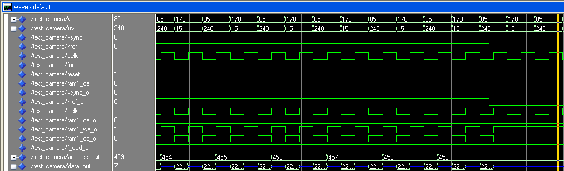

Figure 21: Test Bench Waveform /Output Result

Figure above takes a closer look in to address 454-459. Since the camera module takes alternate pixel data, it can be observed from the figure above that the address only increments at every second rising edge of the clock.

Another point to notice is that data is written at the falling edge of the clock signal, where the signal ram1_we_o (write enable signal for SRAM) goes low at the falling edge of the clock until the next clock rising edge.

Recommendations

This group project means as an aid that help our group to understand the basic design process, implantation tools and techniques , testing process, and finally the operation stage or completed system for the Image Capturing and vector display (camera) project, all these combined with other information’s and tools such as VHDL programming language, Simulation tools, our group project discussion , effort challenge and all team work help us to increase our experiences, skills and more confidence, during this project implementation , we accomplished our goal of designing and implementing this project, and we archived our goal of completing and delivering this systems on time with all expected output as we plan for .

Conclusion

This project was successfully implemented on the DE1 board. The image buffers are used the SRAM in the DE1. Because the limited memory for SRAM. The captured image is stored in the compassed format. The memory is divided into two buffers, the first buffer is used to store the image data captured from the camera, and the second buffer is used for the VGA display. The data exchange could be changed by the control button, in this project; we used the switch SW (0) to act as this freeze button function.

From the test result, the system could display the picture captured from the camera. It also could store the image into the memory. The data exchange between the buffers could be controlled by the freeze button. When the button is off, the VGA monitor could display the camera image real time. When the freeze button is on, the picture displayed on the VGA is freeze at the image stored in the buffer2.

The functionality of the system was verified by our team members using VHDL software simulation tools, a tool which was provided by Quartus II and ModelSim-Altera software to run and successfully simulate the systems, the synthesized circuit is tested to verify its functional correctness and to produce waveform /output results.

The problems exists in this project is that the displayed picture has some flickering, this is because in the design, we use two clocks in the system, one 13.5MHz is input from the camera, another is 25MHz from the clock in the ED1 which is used for the VGA display. Camera part use the 13.5 MHz clock from OV7620 to process the data process and store the result into SRAM, and the VGA part read the data from the SRAM using the 25MHz. Because the SRAM has just one interface, so there are some collide between the camera part and the VGA part. The system used some signals to control this collide. When the collision occurs, the VGA part will recessive and skip a pixel, that cause the flickering the image display.
References

[1] DE1_UserManual_v1018.pdf

[2] OV7620_datasheet.pdf

[3] Project Documentation available at: http://blackboard.rmit.edu.au

[4] Project Specification / Datasheets available at http://blackboard.rmit.edu.au

[5] Jack Keith, demystified: a handbook for the digital engineer, Third Edition,
p. cm. (Demystifying technology series), 1955

[6] http://www.terasic.com.tw/cgi-bin/page/archive.pl?Language=English&No=83#section

[7] http://www.home.agilent.com/agilent/product

Appendices

The following diagram display the OV7620 Pin Out diagrams and descriptions

 | 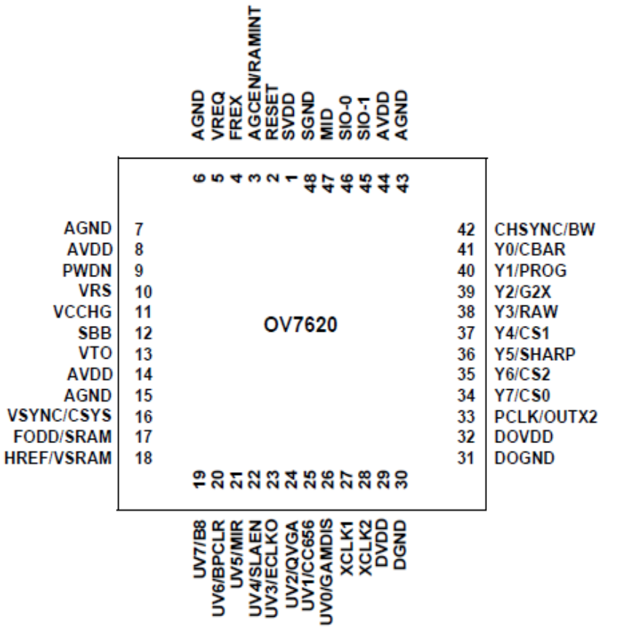
  Array Elements | 664 *492
  Pixel Size | 7.6 *7.6 um
  Image Area | 4.86 *3.64mm
  Electronic Exposure | 500:1
  Scan Mode | Progressive/  interlace
  Gamma Correction | 128 Curve  Settings  See specific
  Minimum Illumination | 2.5 lux@f1.4  0.5 lux @ f1.4  (3000k)
  S/N Ratio | >48dB
  Power Supply | 5VDC,±5%
  Power Requirements | <120mW Active  <10uW standby
  Package | 48 –pin LCC

Figure 22: OV76001 Pin out Diagram

Digital Camera Development Tools / Lab Equipments

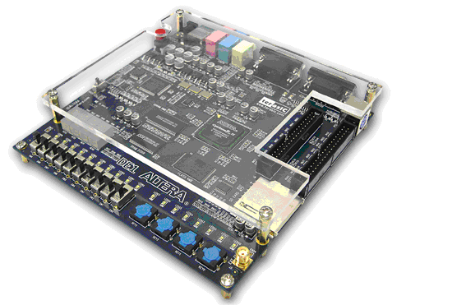
Altera DE1 1 Board
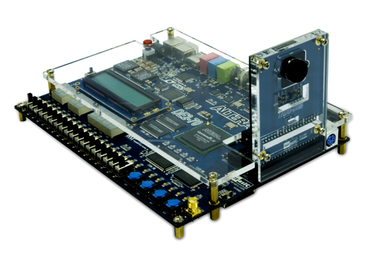
Digital Camera on FPGA System Board.

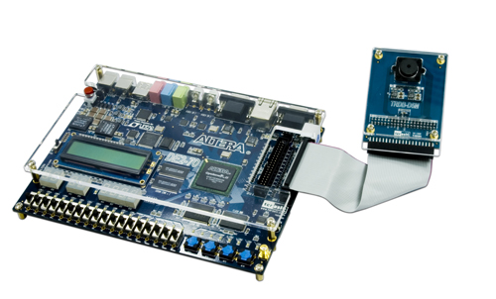
Digital Camera on FPGA System Board.
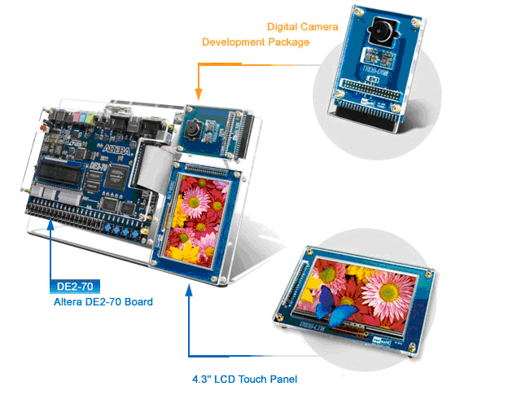
Digital Camera and LCD panel development

Figure23. Digital Camera Development Process

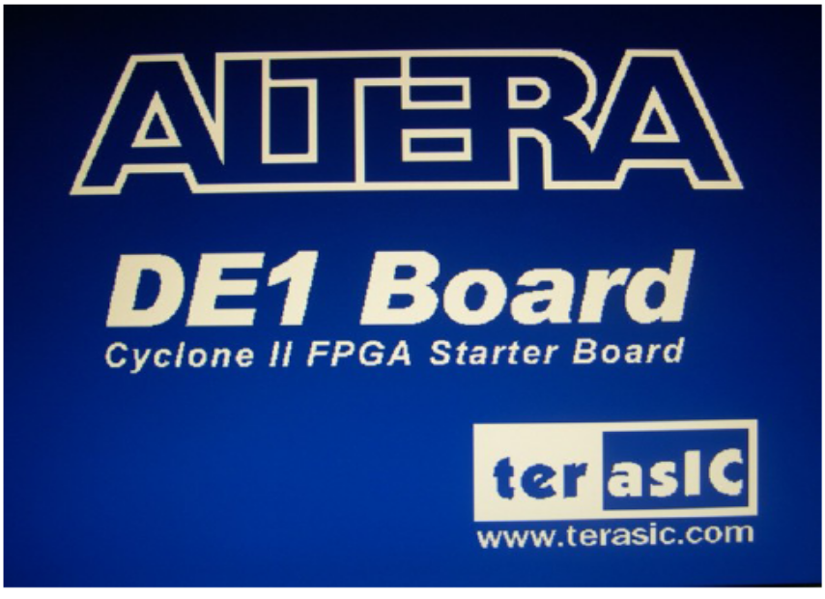

The default VGA output pattern when SW0 is set to DOWN position

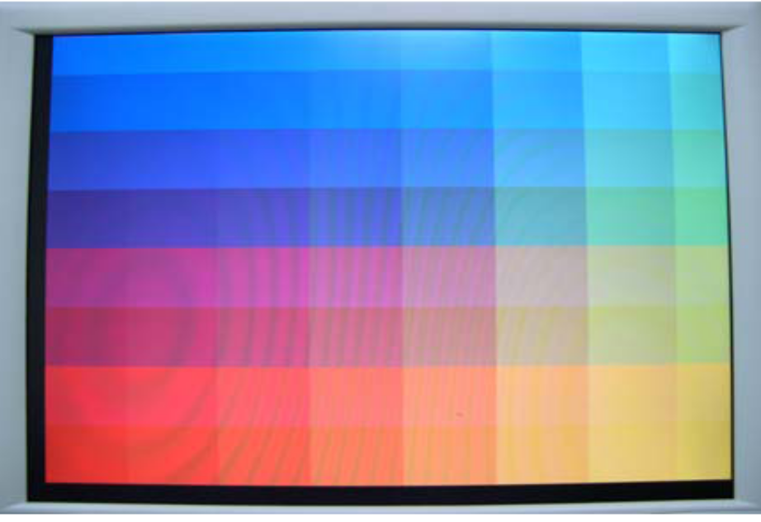

The default VGA output pattern when SW0 is set to UP position

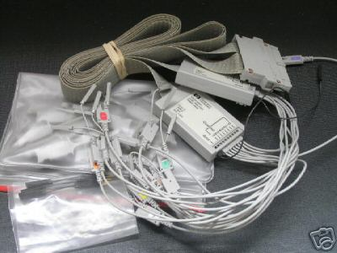
Agilent 54621D logic Analyser Probe Cable
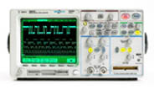

Logical Analyser Probe Cable connect Board with Oscilloscope

Figure24. Digital Camera Equipment Setup /Connection

